


CSCI 1100/1150: On-Site Course Syllabus

Semester: Fall ▪ Year: 2026 ▪ Lecture Sections: 001-004, 800

We, the Using Information Technology leadership, reserve the right to change this syllabus and/or course at any time for any reason.
Welcome to Using Information Technology! Please carefully review this document.

Course Information

Course Overview
Navigate the digital age confidently and creatively in our course, designed to arm you with essential tech skills to make you an informed and enlightened digital citizen. By the end, you'll know how to participate safely and ethically online, evaluate information sources, create tech solutions for real-world problems, and communicate effectively about digital technologies. Dive into Information Literacy, Programming, Data Literacy, Cyber Security, AI and more, to boost productivity and innovation. This course offers a broad exploration of today's digital landscape, preparing you for a future where technology is in constant evolution.

Learning Outcomes
- Engage securely and responsibly in digital communities
- Assess information sources critically for credibility and security risks
- Design technology-based solutions to real-world problems
- Communicate effectively about computing technology
- Apply modern software tools to enhance productivity
- Explore AI and contemporary digital technologies.

Major Topics
- Information Literacy  - Technology Product Literacy  - Introduction to Programming  - The Connected World (Networking)  - Web Literacy  - Data Literacy  - Digital Content Creation and Usage  - AI and Machine Learning  - Cyber Security and Privacy  - Digital Citizenship |  Email Correspondence  - ALL email correspondence related to CSCI 1100/1150 should be sent to csci1100@etsu.edu. (questions, comments, feedback, etc.)  - Please refrain from emailing the instructors and graduate assistants directly.  - Provide your lecture or lab section number (901)  - Subject example: CSCI-1150-901 - Data lab question

Corequisites or Prerequisites
None.

Class Meetings
Find Schedule link in Appendix (ii). The Department of Computing offers different times and modalities for CSCI 1100. Additionally, CSCI 1150 is the lab component of CSCI 1100. Both CSCI 1100 and CSCI 1150 must be taken together.

Instructors
Dr. Christel Young | Assistant Professor  Dept. of Computing, College of Business and Technology
Mr. Ryan Haas | Assistant Director of Using Information Technology & Lecturer  Dept. of Computing, College of Business and Technology

Course Materials

Textbooks and Readings
There are no required textbooks for this course. If a textbook is required, we will use free, open-source collaborations to reduce the burden on students. Materials will be provided throughout the semester through D2L.

Required Technology
Hardware: While many labs are operating system-agnostic, a computer with Windows 10 or newer or MacOS 12 or newer is required to use the desktop version of Microsoft 365 apps such as Word and Excel.
Microsoft 365: Install desktop version via office.com/apps using ETSU credentials.
Internet Access: Consistent and reliable.

Microsoft 365/Office Software Requirement
- Microsoft 365 (formerly Office) is required to complete some labs and may be used throughout the class for writing reflections, processing data, or presenting findings.
  - The online and mobile app versions of Microsoft Excel, PowerPoint, and Word may not be compatible with some lab activities. Additionally, the versions provided through the App Store on macOS computers may differ from the Office version available for installation through your student account.
  - Installing MS 365 apps using your student license: Visit office.com/apps à Login with your ETSU credentials à On the resulting screen, there is an “Install apps” dropdown button in the top right corner. Select “Microsoft 365 apps”.
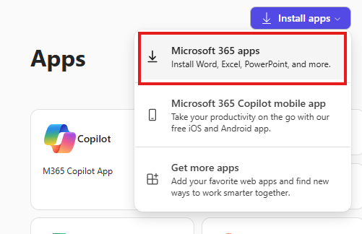

Microsoft 365 IT Assistance & Tips
Contact the ITS Help Desk for assistance with your ETSU Microsoft account and managing installations.
Common error w/ Microsoft logins | If you use another Microsoft account in your web browser, Microsoft’s cookies tend to automatically log you into it! This can be frustrating if you’re trying to log into your student account.  - If you don’t use one account often, consider clearing your browser’s cookies and cache. This will force a fresh login page. Log into the account you plan to use frequently. Whenever you need to log into your other Microsoft account, just open a private or incognito browser Window. When you close this window, the associated browser cookies are cleared, preventing interference with your other Microsoft account.  - If you have two Microsoft accounts that you access frequently (e.g., your work and school account), consider keeping using one web browser (e.g. Firefox) for one account, and another (e.g., Chrome) for the other account.
A pre-existing version of Microsoft Office is already installed | - If you have a pre-installed desktop version of Microsoft 365 that you have already licensed (e.g., such as a home or business license), you may simply keep using that version. Note, however, that while you have an active student status at ETSU, you have access to a student-licensed version should your license expire!  - If you have a new computer and have not purchased an Office license, it is best practice to uninstall Microsoft 365 before attempting to install the version provided through your student account. The ITS Help Desk can assist you!

Course Expectations

Expectations from the Instructor
- Share lesson content in a timely manner.
- Be attentive to students and their questions.
- Be available to answer questions and provide help related to the course.
- Make a genuine effort to help students achieve course objectives.
- Devote considerable time and effort to the course.

Expectations from Students
- Regularly check and use the D2L course sites for CSCI 1100 and CSCI 1150.
- Be attentive and participate in class activities.
- Complete assignments on time.
- Meet the course objectives sincerely.
- Devote considerable time and effort to the course, including spending 2-3 hours outside class for every hour in class.

Encouraged Student Behaviors
- Ask appropriate questions when unclear about course content.
- Participate actively in class discussions and activities.
- Understand that peers can also be a source of learning alongside the instructor.

Course Format and Evaluation Policies

Course Format
CSCI 1100 should be paired with CSCI 1150. Students will take CSCI 1100 and CSCI 1150 in the same semester in which CSCI 1100 will be the lecture portion of the course, and CSCI 1150 will be the lab portion of the course.
CSCI 1100 Lecture Delivery | CSCI 1150 Lab Delivery
On-Site Lecture Delivery – This modality requires that the students and instructors attend the class meetings in person in an on-campus location. | On-Site Lab Delivery – This modality requires that the students and their lab facilitators to attend the lab meetings in person in an on-campus location.
Asynchronous Online Lecture Delivery – This modality does NOT require the students and instructors to attend class at a prescribed time. Instead, the course materials are delivered via the D2L Brightspace learning management system via prerecorded lecture videos, interactive activities, and a variety of other media. | Asynchronous Online Lab Delivery – This modality does NOT require the students and instructors to attend class at a prescribed time. Instead, the lab materials are delivered via the D2L Brightspace learning management system via lab instruction documents and other supplemental links and media.
Course materials and assignments will be available through the course website: https://elearn.etsu.edu.You should check this site daily for updates and announcements. A tentative assignments schedule is provided separately in D2L and may change throughout the semester to allow extra time for concepts or accommodation for university scheduling.

Evaluation Policies

Personal Learning Labs
Personal Learning Labs are designed to deepen your understanding of course concepts by tackling individual projects aligned with your interests and the week’s topics. These labs – whether you’re exploring online privacy, building a website, investigating AI, or examining how computers connect globally – are a chance to apply what you’ve learned. You’ll work on a lab assignment each week (aside from make-up lab weeks) and can utilize campus resources like the Center for Academic Achievement. All labs must be completed individually, without the use of generative AI, unless otherwise specified.
If assistance is received to complete the assignment, credit must be attributed on the deliverable in the following format:
Resource: <Person’s name, position> or <Website link>
Assistance Received: < A statement of the assistance you received.>
Individual Contribution: <What you, as the individual completing the assignment, did with the help received to ensure the integrity of the work submitted>

For students enrolled in the on-site lab sections, the goal is to complete lab work during the scheduled lab session. If you do not complete the lab work during class, you may continue working asynchronously to present your completed lab work to your instructor during the next lab session. Note: Your instructor may not accept the previous week’s lab submission if you did not attend during the class session in which the lab activity was introduced.
For students enrolled in online lab sections, note that all lab work should be completed by the common weekly deadline for Lab, Quiz, and Exit Ticket assignments (Sundays, 11:59 EDT).

Quizzes
Weekly quizzes will cover topics we discuss in our weekly lesson materials (e.g., videos, lesson slide sets, or notes). You will be allowed two attempts per quiz (some questions will change) to help you master the material. If you use both attempts, your quiz grade will be the higher of your two attempts.
Quizzes will be given on D2L, consisting of multiple-choice, true/false, fill-in-the-blank, and matching questions. Quizzes should be completed by the common weekly deadline for Lab, Quiz, and Exit Ticket assignments (Sundays, 11:59 PM EDT).
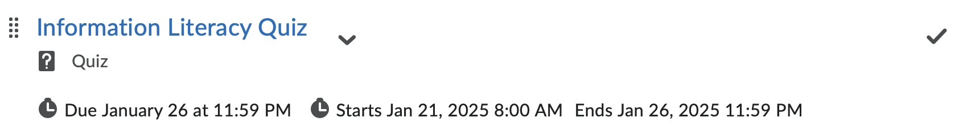

Exit Tickets
An Exit Ticket is a short, completion-based quiz used to gauge your perceived understanding and enjoyment of each topic AFTER you have reviewed the weekly lecture materials (e.g., videos, slide sets, or notes).
Your feedback helps the instructors and lab facilitators gauge how well the class understood the material and lets you reflect on your learning to ensure you are on the right track!
Your Exit Ticket will be found toward the bottom of your modules in your CSCI-1100-001 D2L site. It should be completed by the common weekly deadline for Quizzes and Exit Ticket assignments (Sundays, 11:59 PM EDT).
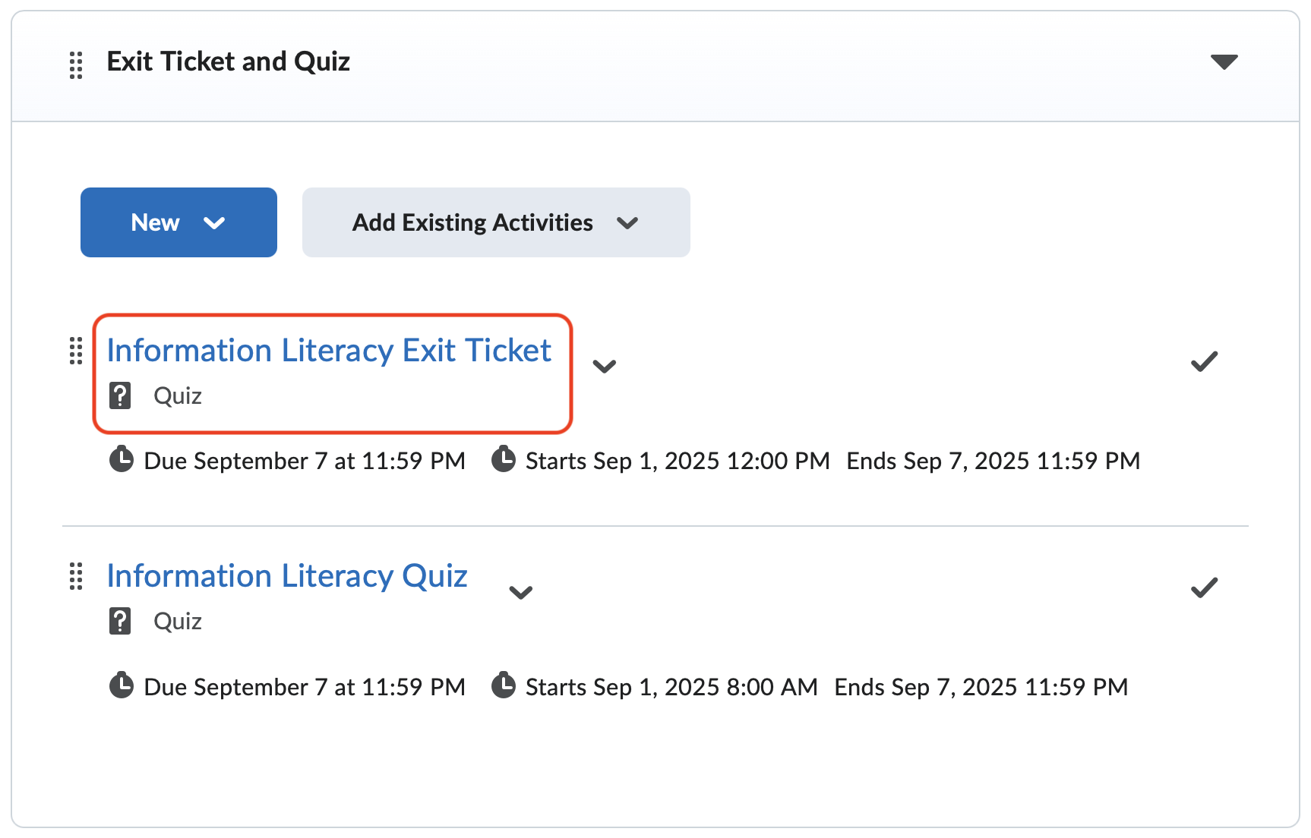
* Please wait for us to share each topic’s lesson materials before attempting Quizzes and Exit Tickets so you can review them in preparation. There is no Quiz or Exit Ticket due on Week 1!

Digital Citizenship Audit (half of grade)
Portfolio demonstrating literacy competencies in a creative format.
Overview: Demonstrate your competence in six digital citizenship literacy areas through practical application and critical reflection.
Key Literacy Areas:
- Information Literacy: Evaluating online information credibility
- Data Literacy: Analyzing and visualizing data using Excel
- Web Literacy: Understanding website accessibility principles
- AI Literacy: Critically engaging with AI tools or concepts
- Cybersecurity Literacy: Implementing security practices
- Microsoft 365 Proficiency: Using Word, Excel, and PowerPoint effectively
The Digital Citizenship Audit cannot be made up or submitted late.

Final Grade
The final grade in the course is based on the following breakdown:
Item | Fraction of Overall Grade
Personal Learning Labs | 1/6
Quizzes | 1/6
Exit Tickets | 1/6
Digital Citizenship Audit | 1/2
Note: The DCA is your final project at the end of the semester. Prior to its completion, your overall grade will be calculated as 1/3 Labs + 1/3 Quizzes + 1/3 Exit Tickets.
The course will use the following grading distribution:
Letter Grade | Percentage Range
A+ | 97% - 100%
A | 93% - 96.99%
A- | 90% - 92.99%
B+ | 87% - 89.99%
B | 83% - 86.99%
B- | 80% - 82.99%
C+ | 77% - 79.99%
C | 73% - 76.99%
C- | 70% - 72.99%
D+ | 67% - 69.99%
D | 63% - 66.99%
D- | 60% - 62.99%
F | 0% - 59.99%
Please check your grade often to ensure that you are on track for successful course completion.

Course Policies

Participation
While participation is not directly part of your final grade in this course, you should regularly access your CSCI 1100 and CSCI 1150 D2L sites, engage with the materials provided to you, and complete assignments. To ensure your success in this course, we recommend the following participation strategies:
- Ask questions, be curious, be positive, be supportive.
- Access each piece of content in the course. Content includes documents we’ve posted, videos we’ve posted, links we’ve shared, and anything else posted to the D2L course website.
Please note that it is tough to catch up in any course once you have fallen behind, and the course materials are essential since they form the foundation of your computing knowledge. Please do everything you can to attend class.
When you do have to be absent, you are still responsible for material, assignments, finding out what you missed, making sure that any work due that day gets to the instructor, and getting any assignments or materials handed out during your absence so that you can prepare for the next class.

Late Work and Make-Up Work
As our Evaluation Policy outlines, we typically expect all assignments to be submitted on time. However, we recognize that life can be unpredictable, and there are times when extraordinary circumstances beyond your control may prevent you from meeting deadlines. If you face such extenuating circumstances, we encourage you to contact us as soon as possible—preferably before the assignment's due date. Let's explore a few examples to illustrate what may qualify as extenuating circumstances:
- Medical Emergencies or Illness: This would be deemed an extenuating circumstance if you suffer a severe illness or injury requiring hospitalization or substantial recovery time. For instance, if you are involved in an accident and need surgery, thus overlapping with assignment deadlines, promptly reach out with documentation, like a medical certificate. We will work together to adjust your deadlines accordingly.
- Family Emergencies: Situations such as a close family member's sudden death or severe illness necessitating your immediate attention and presence also qualify. If you must travel unexpectedly due to a family emergency, causing you to miss classes and deadlines, please explain your situation, and we will arrange for extensions on your assignments.
- Natural Disasters: If natural disasters disrupt your ability to complete assignments, this is considered beyond your control. If such disasters affect your living conditions or access to utilities, communicate your circumstances to us. Once things stabilize, we will provide you with the necessary time extension to submit your work.
- Unforeseen Mental Health Challenges: If you encounter significant mental health concerns diagnosed by a professional affecting your academic performance, this, too, is recognized as an extenuating circumstance. Should you find yourself struggling with mental health challenges, please consult with a professional and inform us. We can discuss a modified submission timeline with appropriate documentation and offer additional support where possible. Learn more about the BucsCARE services at https://www.etsu.edu/bucscare/default.php.
In all these scenarios, the most crucial steps are to communicate your situation to us early, provide any necessary documentation, and work together to develop a plan that allows you to complete your assignments within a revised timeframe. We aim to support you through these challenges while ensuring your academic progress.
We will provide at least one week for making up one missed lab assignment (see the assignments schedule). Late work submitted outside of these windows will not be accepted.
Exit Tickets and Quizzes cannot be submitted late. We will drop your 3 lowest Exit Ticket grades and one lowest Quiz grade from your overall grade.

Email
Please refrain from emailing the instructors and graduate assistants directly.
Instead, use csci1100@etsu.edu for all email communication (questions, comments, feedback, etc.) related to CSCI 1100/1150.
Your ETSU email is how you communicate with us outside of class and during office hours. Please allow up to two business days (M-F) for a response. We will likely respond before then, but we will try to respond within 48 hours on weekdays. If you have questions about an assignment, send an email. It is your responsibility to make sure assignments are submitted on time. Waiting for us to respond to an email within 48 hours of the assignment's due date will not excuse a late assignment.
Please follow the following guidelines when emailing us to ensure we can respond to you most efficiently:
- Always include an informative subject line that includes the course number and section, followed by a brief explanation of the concern, e.g.,
  - CSCI-1150-XXX – Questions About Lab 3 Grade
  - CSCI-1150-XXX – Scheduling Office Hours with You
    - where “XXX” is your section number, e.g., 001, 002, 201, 901, etc.
- If you are emailing regarding needing help on an assignment, do your best to include the following:
  - An explanation of what the problem you are having is.
  - An explanation of what you have tried so far and the outcomes of those trials.
  - Screenshots of the relevant work and/or a copy of your zipped work, noting where the issue is in the work.
- If you are emailing regarding scheduling a meeting with one of the instructors or graduate assistants, do your best to include the following:
  - What would you like to cover during the meeting?
  - Your preference for meeting in person or via Zoom.
  - A list of dates and times you are available for the meeting.
    - Please email a request to meet at least 48 hours before the time you suggest we meet. More than likely, if you email us an hour before the intended meeting time, we won’t be able to figure out the details in time.

Grade Appeals
As a student, it is your right to appeal a grade that you feel is unjust or incorrect. You may appeal an assignment grade or the final grade in the course.
In the case of an assignment appeal, the appeal should be made from your official ETSU email address to csci1100@etsu.edu within three weeks of receiving the grade. This appeal should contain the following:
- Written justification for the appeal.
- Any evidence to support the appeal.
- A proposed resolution.
In the case of a final grade appeal, per University policy, your first course of action is to schedule a meeting with your instructor: “A student contacts the instructor to schedule a meeting (in-person, phone, or video) within ten (10) business days of the official start of the following semester, not including Summer terms. If the instructor is no longer employed at ETSU, the student moves directly to Level Two” [Undergraduate Grade Appeal Policy].

Academic Honesty and Misconduct

What's Expected of You
You're expected to follow ETSU's Honor Code and maintain academic integrity throughout this course. All work you submit must be your own original effort.

What Happens If You Violate These Policies
If you commit academic misconduct, you could face consequences ranging from reduced grades on specific assignments to failing the entire course. When violations occur, your instructor will initiate formal misconduct procedures and notify both you and the Dean. You have the right to appeal any decisions through the university's Academic Misconduct Procedures.

Understanding Plagiarism
You're committing plagiarism when you use another person's ideas, words, or work without giving them proper credit—even if you only use a small portion. This applies to all sources including internet content, and it includes reusing your own previous work without getting your instructor's written approval first. When you do use outside sources, you must cite them using recognized scholarly formats like APA or MLA.

Your Responsibilities in This Course
Complete Your Own Work: You must complete all assessments (quizzes, exit tickets, labs, and your final project) independently. While you're encouraged to learn from external resources to better understand topics, you cannot plagiarize.
Use AI Appropriately: Although you'll be studying AI as a course topic, you may not use generative AI platforms to complete your assignments—this violates the honor code and only cheats yourself out of learning. You may use AI tools as planning aids, but you must never submit AI-generated work as your own.
Remember: You can complete this work, and these policies exist to help you grow your competency with computing and technology concepts.

Other Resources

Disability Services
It is the policy of ETSU to accommodate students with disabilities, pursuant to federal law, state law and the University’s commitment to equal educational access. Any student with a disability who needs accommodations, for example, arrangements for examinations or seating placement, should inform the instructor at the beginning of the course. Faculty accommodation forms are provided to you through Disability Services in the D.P. Culp Center, Suite 390, telephone 423-439-8346.
Visit the Disability Services webpage for more information at https://www.etsu.edu/students/ds/

Academic Support and Mental Health Services
The BucsCARE website is meant to be a resource for students and student referrals. BucsCARE includes the most referenced offices and campus resources in various categories. This page includes a link to ETSU’s “Need Help ?” site, which comprehensively lists other resources by topic area.
Learn more about the BucsCARE services at https://www.etsu.edu/bucscare/default.php.

Library Resources
The Sherrod Library extends access and services to all currently enrolled ETSU students. These services include traditional library patronage via Research and Instructional Services, Technology, and Content Services.
Learn more about the Sherrod Library by visiting https://libraries.etsu.edu.

Lending Technology and Personal Librarian Programs
With many in our region lacking internet services and/or access to a computer, the ETSU Libraries, Dean of Students, Information Technology Services (ITS), and Student Life and Enrollment (SLE) began a collaboration to solve this enormous problem many of our students faced in completing course work and the possibility of dropping out. https://libraries.etsu.edu/tech/ltp

ITS Help Desk
The Information Technology Services (ITS) Help Desk is the best resource for most technical problems. Find answers to common questions on the Help Desk website, call, email, or stop in to see them on the first floor of the Sherrod Library. (423) 439-4648 itshelp@etsu.edu

Desire2Learn (D2L) Online Help
The D2L Help Student Home has many answers to D2L-related questions. Additionally, this link has a knowledge base explaining essential D2L components and their use. If you still have trouble finding what you need, contact the Help Desk.

Turnitin Plagiarism Detection
Turnitin is a plagiarism detection service available to ETSU students and faculty. This tool compares student-written work against a comprehensive database of other work and various internet sources. Faculty may employ this service for some or all written assignments to help you learn to cite sources accurately and ensure academic integrity. Learn more on the Turnitin home page.

ETSU Technical Resources
Many other technical resources can be found on the Online Help webpage.

ETSU Syllabus Attachment

URL: https://www.etsu.edu/curriculum-innovation/syllabusattachment.php

Disclaimers

Syllabus Changes
The instructor reserves the right to make changes to this syllabus as necessary. If changes are necessitated during the course term, the instructor will immediately notify you by email and on the course site, posting both the notification and the nature of the change(s).

Schedule Changes
The instructor reserves the right to change the assignments schedule as necessary. If changes are necessitated during the course's term, the instructor will immediately notify you by posting both the notification and the nature of the change(s) on the course site.

Appendix

i. Course Offerings and D2L Sites
Using Information Technology is divided into lecture and lab sections. Please ensure that you have registered for both CSCI-1100 (lecture) and CSCI-1150 (lab).

Your D2L Lecture Site:
Your lecture site contains lecture resources, Quizzes and Exit Tickets.
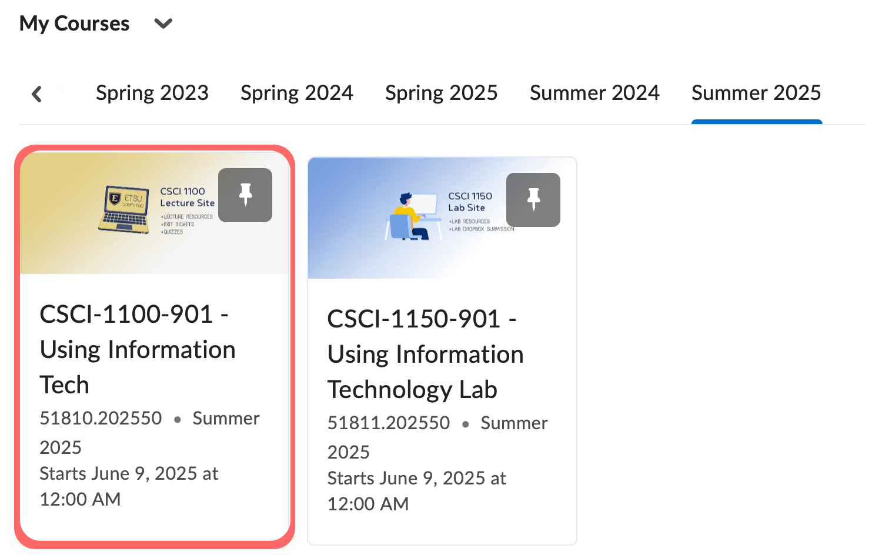

Your D2L Lab Site:
Your lab site contains lab resources and the Dropbox folders where you will submit your labs.
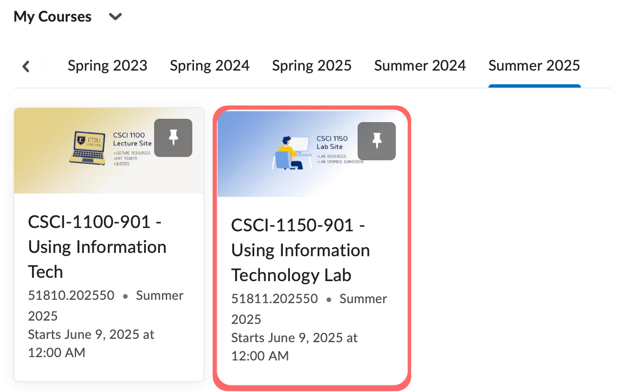

ii. Your Assignments Schedule (lecture and lab)
Fall 2026 Assignments Schedule

